EC PROJECT

Section-C

Table Number-7

Name and Roll Number of Group Members

Aarsh Kaushik(220014)

Ayush Kumar(220265)

Project Title-Smart Lights and Fan Control Using PIR Sensors and Bluetooth Communication

**Q1.) What problem are you trying to solve and why is it important/interesting?**

**Answer**: In this project, We are trying to automate room monitoring and appliance control based on the number of people present. The system uses PIR sensors to count how many people enter or exit a room. This count can be used to control a relay, which can switch devices like lights or fans on or off automatically. The data is also sent via Bluetooth to a mobile app, which shows the current people count and logs entry/exit times as well as provide a rough estimate of the appliance usage and the cost incurred through it.

This problem is important because in many places like homes, offices, classrooms, or public spaces, energy is wasted when lights or fans are left running in empty rooms. Manual switching is not always reliable. An automatic solution helps save energy, adds convenience, and improves monitoring.

**Q2.)** **What are the existing solutions? Describe a few of them and list any shortcomings in them. Is your solution approach unique in some way?**

**Answer:** Yes there are various existing solutions for controlling electrical appliances based on space occupancy some of which include

1.)**CCTV with AI-Based People Counting**

* Some advanced systems use cameras and AI to count people.
* **Shortcoming:** Good for monitoring but Expensive, requires a lot of processing power, raises privacy concerns, and not beginner-friendly.

**2.**)**Motion Sensor-Based Auto Control (Single PIR)**

* Some systems use a single PIR sensor to detect motion and turn devices on/off.
* **Shortcoming:** It can’t count people or distinguish entry/exit. Devices may turn off even when someone is still inside if there's no motion.

3.)**Commercial People Counters (like retail footfall counters)**

* Used in malls or stores with infrared or laser beam sensors.
* **Shortcoming:** Usually expensive and not connected to home automation. No mobile app integration for live tracking or control.

While our system may not match the high-level monitoring of CCTV solutions, it is a much more affordable and easy-to-use method for controlling appliances based on how many people are in the room and provides monitoring to some extent through a mobile app displaying the entry exit time stamps in a day.

**Q3.) What resources do you require for completing the project.? Give a breakup of tasks that you need to accomplish week by week to complete the project.**

The components required for this project were as follows:

1.)Arduino Nano – 2

2.)HC-05 Modules-3(Bluetooth module)

3.)1k resistors-9

4.)PIR motion Sensors-2

5.)Dual Channel Relay Module-1

6.)Led with 220 ohm resistor-1

7.) Jumper wires-as per connections

Time Line:-

In the **first week**, the focus was on getting familiar with all the hardware components used in the project, such as the PIR sensors, Arduino Nano, relay module, and HC-05 Bluetooth modules. Basic Arduino programming was practiced, and each component was tested individually to ensure proper functioning. The core task for this week was to implement the **people counting logic** using two PIR sensors to detect entry and exit. A counter was maintained to track the number of people in the room, and the relay was controlled based on the count — turning ON when at least one person was present, and OFF when the room was empty.testing was done using LEDs(Since the relay implementation was omitted during testing, an LED was used instead to demonstrate the concept of appliance control based on room occupancy. This allowed us to showcase the system’s core functionality without risking hardware damage or dealing with high voltage components.)

In the **second week**, the goal was to establish **Bluetooth communication between two Arduino Nanos** using HC-05 modules configured in Master-Slave mode. The Arduino handling the people counting acted as the master and sent the current count and ON/OFF status wirelessly to the second Arduino, which was responsible for controlling the relay. Reliable data transmission and response between the two boards were ensured through testing and debugging.

In the **third week**, the focus shifted to developing a **mobile app** using **Kodular** The app was designed to connect with the HC-05 Bluetooth module and display real-time data, including the current people count, entry and exit timestamps, and the status of the connected appliance (ON/OFF). Basic app features such as reset, data logging, and live status updates were implemented. The final system successfully combined hardware, wireless communication, and a user-friendly interface to offer a cost-effective smart room monitoring solution.

**Implementation Details:**

Given Below is the Circuit Diagram for our Project

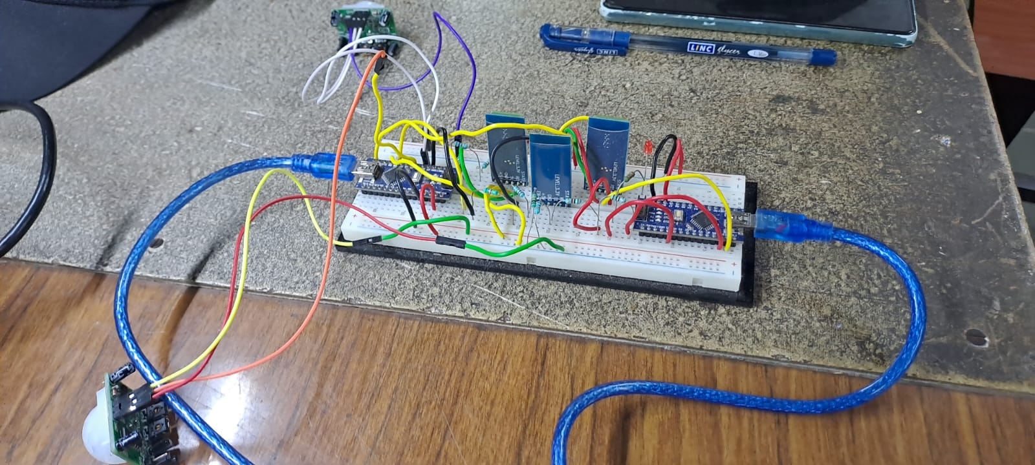

Here is the block diagram for understanding the circuit and data flow

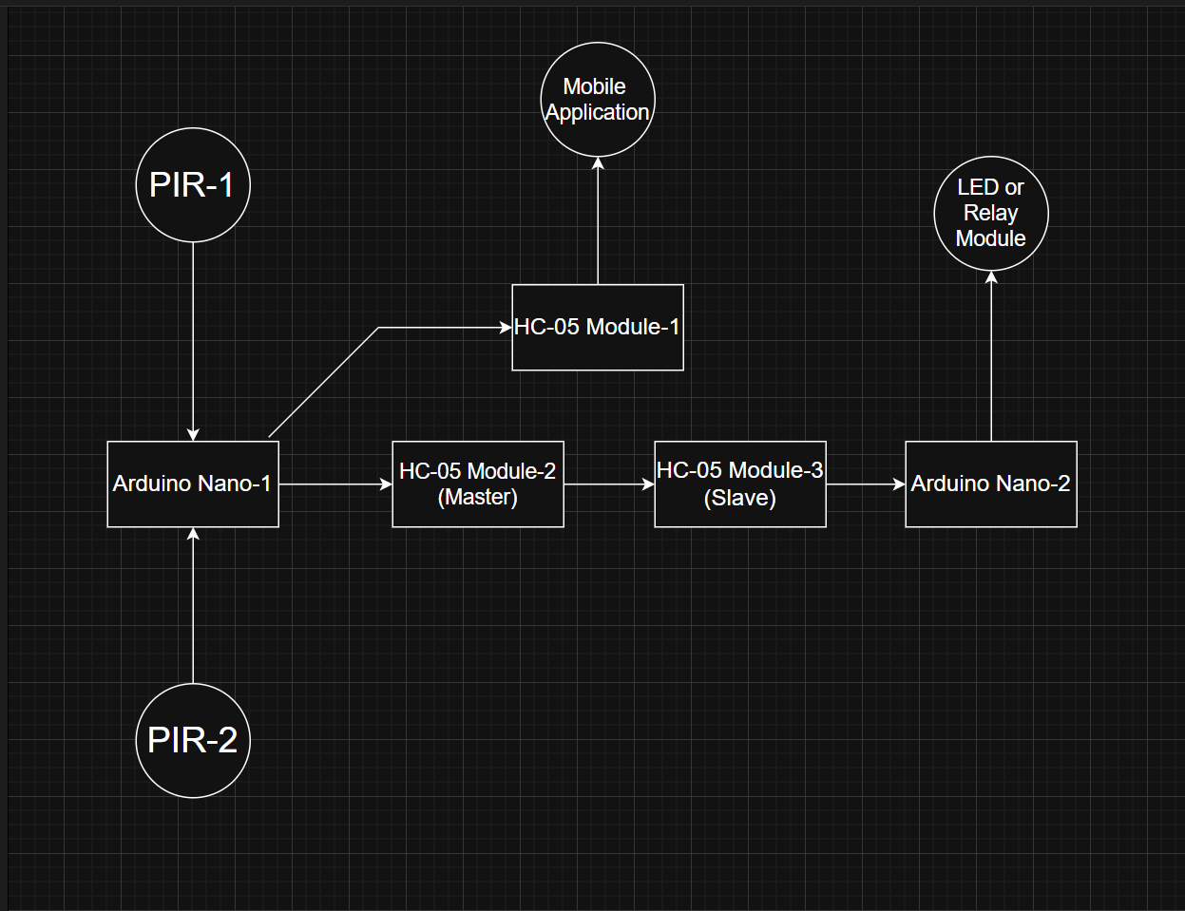

The two PIR detect whether a person entered or exit the room this data is then sent to HC-05 1 which transfers data to the mobile app and the app displays the timestamp as well as the total people currently in the room this same information is passed from HC-05 2 to HC-05 3 which are configured in master slave configuration this data is processed by nano 2 and takes decision if people count becomes non zero it sets the led/relay input to high if it is zero it sets it to low

Arduino Code Details :

For Nano 1

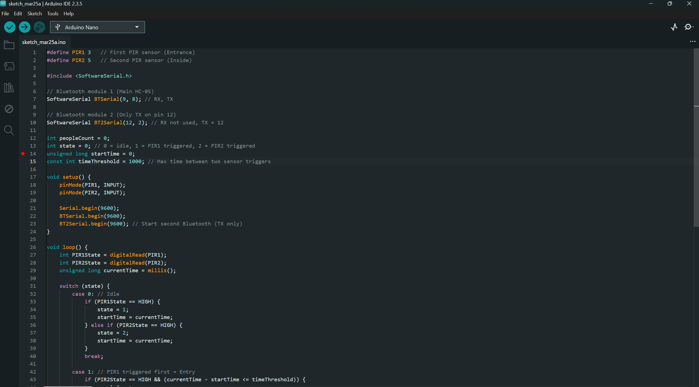

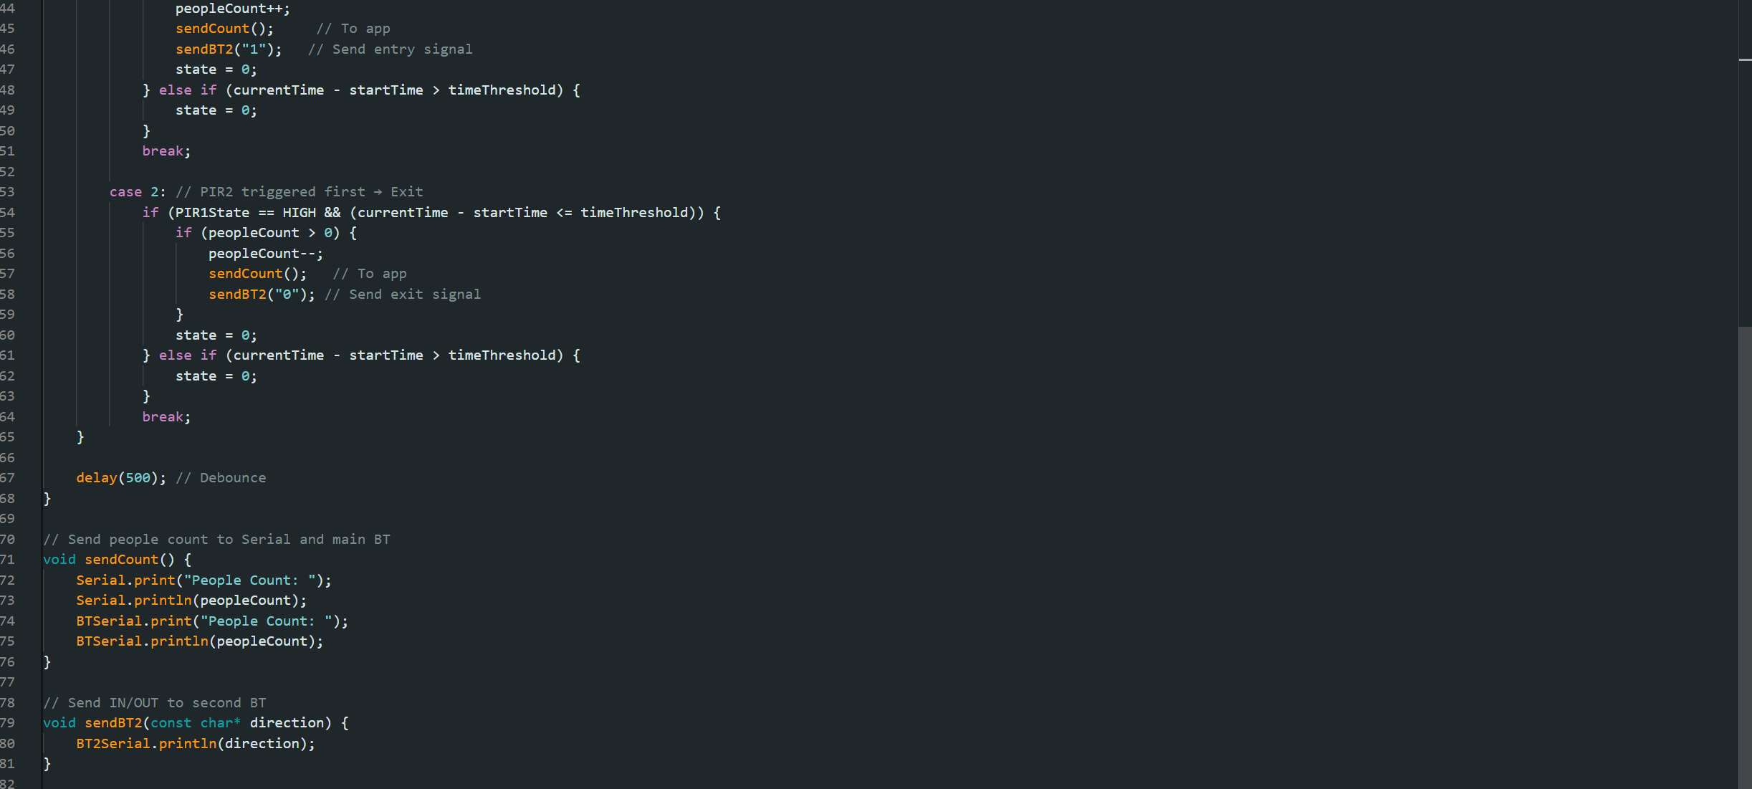

The loop function take input the time at which pir sensor 1 and pir sensor 2 were triggered lets call it t1 and t2 we define a threshold as t0 the Arduino sends entry when t2>t1 and t2-t1<=t0 in this case the people count is incremented and the message is conveyed to the two hc-05 modules it call exit when t2<t1 and t1-t2<=t0 in this case the count in decremented and data is sent to the second Arduino and the app

Here is the code for the second Arduino Nano

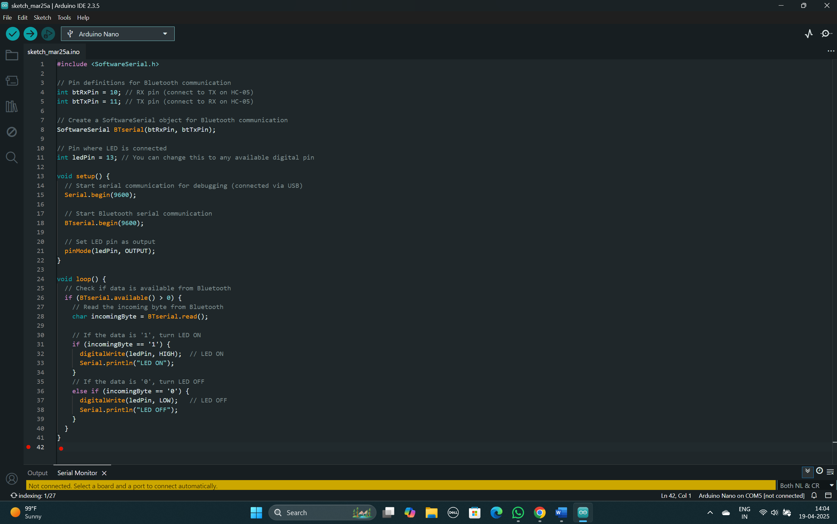

This code receives data from the slave HC-05 and processes if ‘1’ is sent then it writes the output of led/relay high else it writes the output as low

Application Details :

The following section provides the UI/UX design as well as the backend logic for the mobile application

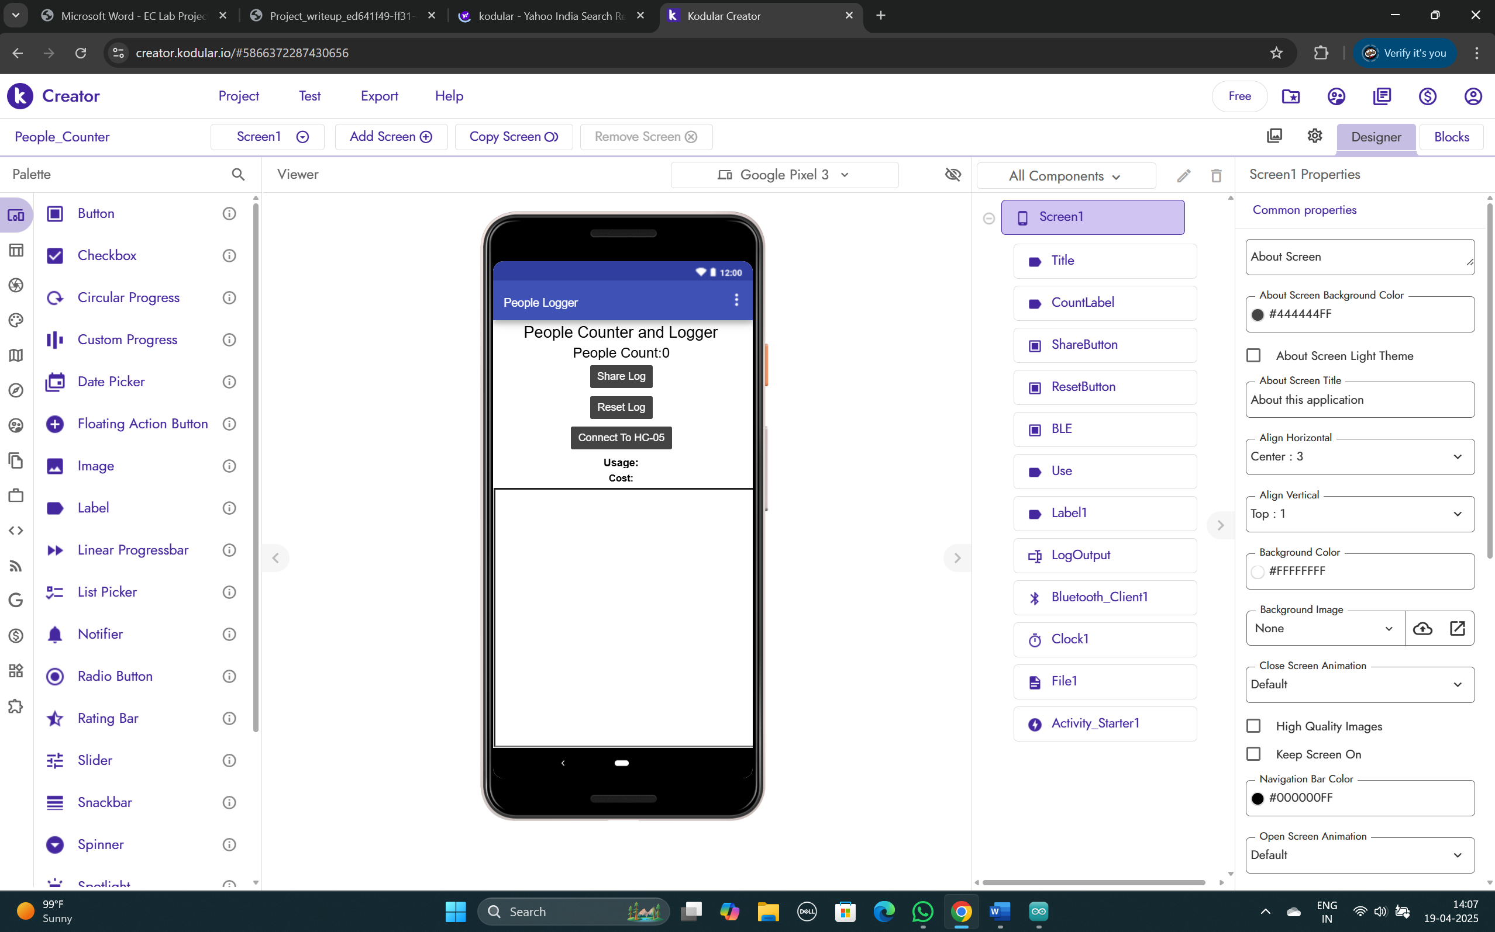

Here is the backend logic 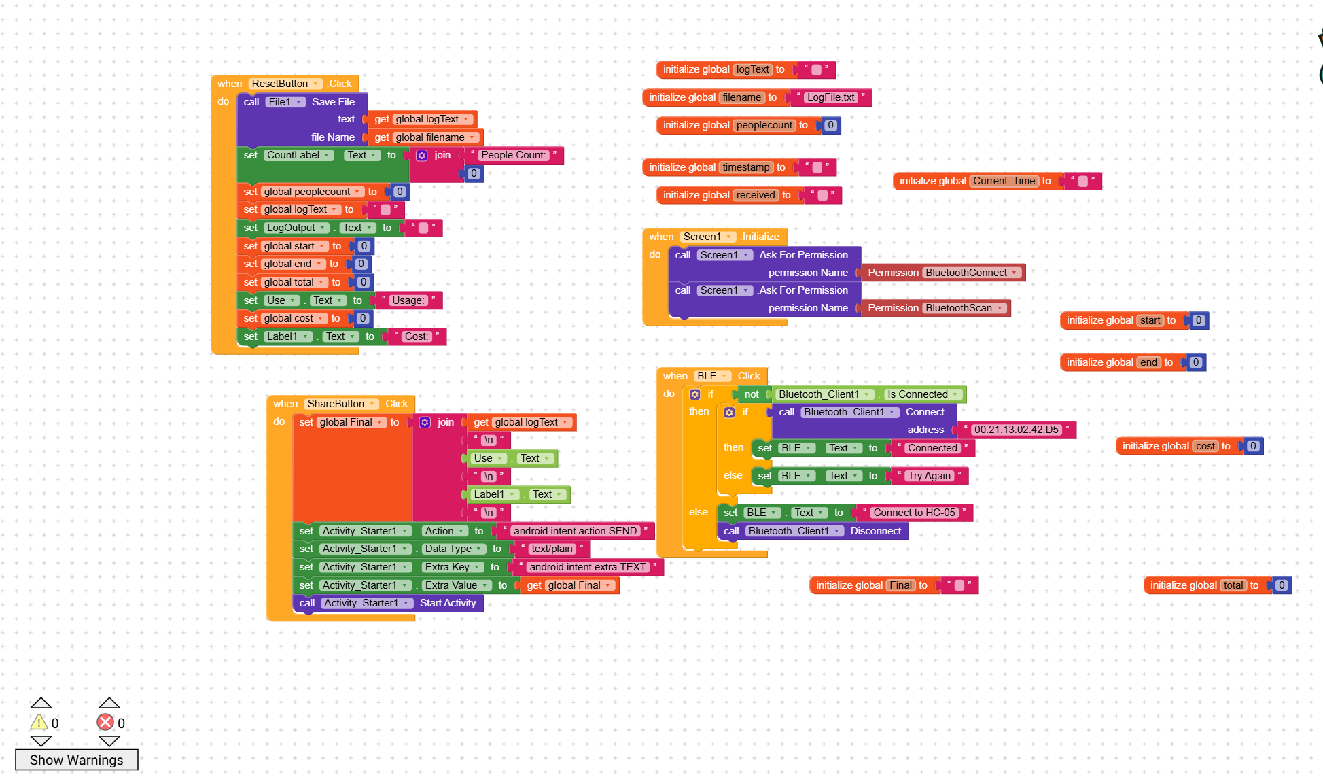

These logics are implemented when the buttons provided in UI design are clicked also provided are the initialization of variables

For ease of implementation

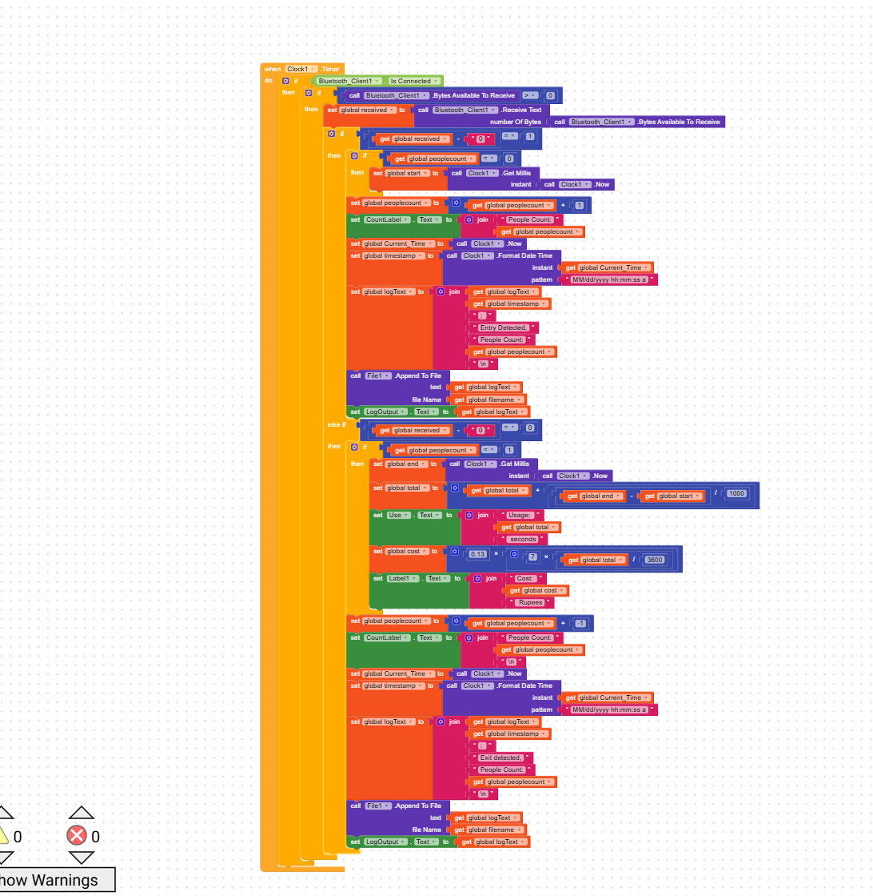

This Logic is implemented at every positive edge of clock wherein it takes data from the Bluetooth client to deduce entry or exit and then use it to update the people count get the current time and log the entry at the text box provided in the ui design

Results:

The developed system was able to detect and track people entering and exiting a room using two PIR (Passive Infrared) sensors. Based on the real-time count, the Arduino controlled connected leds(for ease of demonstration relay was omitted)—turning them ON when the room was occupied and OFF when it was empty. This automation helped reduce unnecessary power usage.

The Bluetooth module (HC-05) successfully transmitted the occupancy data to the mobile application. The app displayed the live count of people inside the room, along with entry and exit times. The log feature allowed users to monitor activity over time and included options to reset or share the log when needed.

During testing, the system functioned reliably for individual entries and exits. The integration between the hardware and mobile application was stable, with smooth data updates and consistent performance across multiple test runs.

Here are some screenshots of our project in action

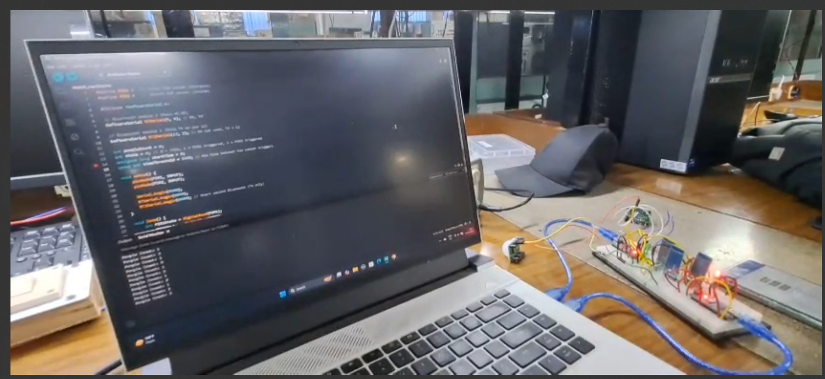

We see that at non zero count the led lit up please note that the relay implementation was omitted for the ease of demonstration

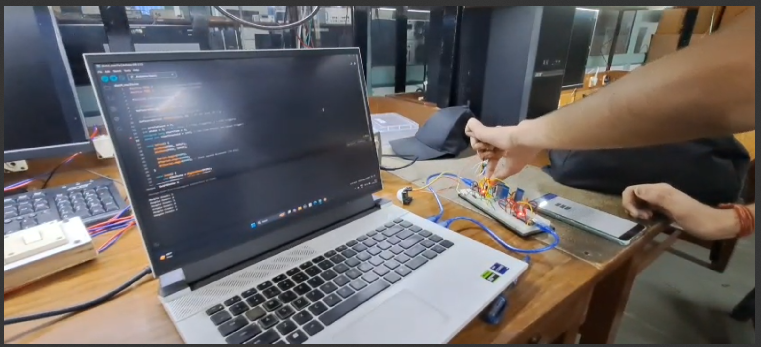

When the people count reached zero the led turned off

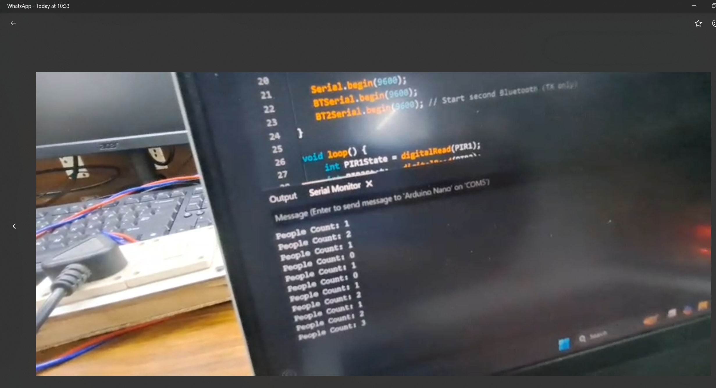

The Arduino serial printed the people count based on the time on which the two pir sensors were triggered

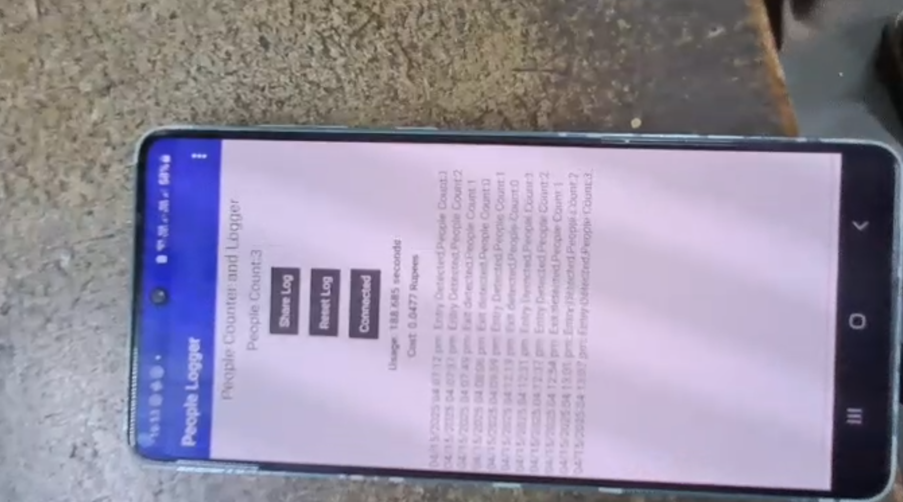

Our mobile application successfully updated its count in accordance to data received from Arduino via hc05 and the count matches with the one printed on the serial as well as it also provided with the time the room was occupied that is (time when people count was 0 – time before it when there was a first non zero count) as well as rough estimate of the cost incurred.